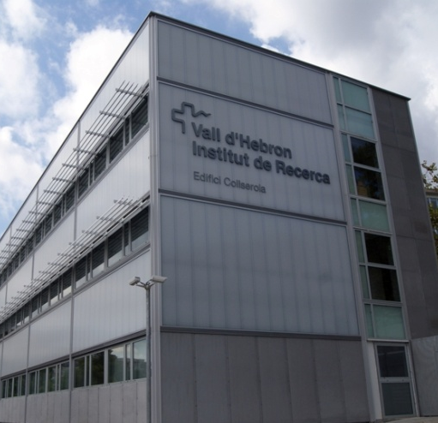
The Vall d'Hebron Research Institute (VHIR) is a public sector institution that promotes and develops the research, innovation and biosanitary teaching of the Vall d’Hebron University Hospital. Through the excellence of our research, we identify and apply new solutions to the health problems of society and we contribute to spread them around the world.

In April 2015, the Vall d’Hebron Research Institute (VHIR) obtained the recognition of the European Commission HR Excellence.
This recognition proves that VHIR endorses the general principles of the European Charter for Researchers and a Code of Conduct for the Recruitment of Researchers (Charter & Code).
Thus, there are no restrictions of gender, national origin, race, religion, sexual orientation or age and candidates with disabilities are strongly encouraged to apply.
Predoctoral position
Obstetrics, Pediatrics and Genetics – Graduate Technician

The Research Group Maternal and Fetal Medicine, Department of Obstetrics, University Hospital Vall d’Hebron is one of the largest maternity units in Catalonia and Spain. It is a tertiary referral center accredited by the European Council and the College of Obstetrics and Gynecology (EBCOG) and the European Association of Perinatal Medicine (EAPM) as a training center with 14 residents. The Fetal Medicine Research Group works closely with the Research Institute Vall d’Hebron (IR-HUVH), which promotes basic and applied research in the laboratories of HUVH.
More information can be found here.
JOB DESCRIPTION
Education and qualifications:
Required:
- Predoctoral Degree holder
- Speciality Obstetrics and Gynaecology
- Area: Maternal-Fetal Medicine
- Theme: Prevention of preterm birth
Preferred:
- T Specialization in Obstetrics and Gynaecology concluded at least a year ago.
- Research experience in the area of maternal-fetal medicine for at least a year.
- Preferably with experience in research in the prevention of preterm birth.
- Will be assessed positively the development of studies and publications in this field.
Main responsibilities and duties:
- Addition to a research project in the field of the prevention of preterm birth to compare the management of cervical pessary depending on the experience of the researcher in a risk group of expectant mothers.
- Monitor the inclusion of patients, the collection of data to DCN, the evolution of the study and of the operation and publication of results.
Labour conditions:
- Work and Services Contract
- Part-time position (20 hours per week)
- Gross annual salary: 11,050.00 euros
HOW TO APPLY
Applicants should submit a full Curriculum Vitae and a cover letter with the reference Obstetrics and Gynecology to the following email addresses: (mgoya@vhebron.net) and (seleccio@vhir.org).

